**‘Hope Hack’ Social media toolkit**

Please use the image and suggested copy below when promoting ‘Hope Hack’ on social media.

Alternatively, feel free to share our posts directly.

Facebook: [(2) Facebook](https://www.facebook.com/eahscp/photos/a.962917087159403/6178193275631732)

Twitter: [(17) East Ayrshire HSCP on Twitter: "Want to have your say on important issues? If you’re aged 14 – 24 and living in East Ayrshire, the ‘Hope Hack’ needs you! Mon 12 June, @AyrshireColl Kilmarnock, 10am - 4pm Featuring John Loughton of @daretolead Find out more and register: https://t.co/n3xZTafn1c #EAHopeHack https://t.co/b6M6j3gGjZ" / Twitter](https://twitter.com/eahscp/status/1659154393785147393)

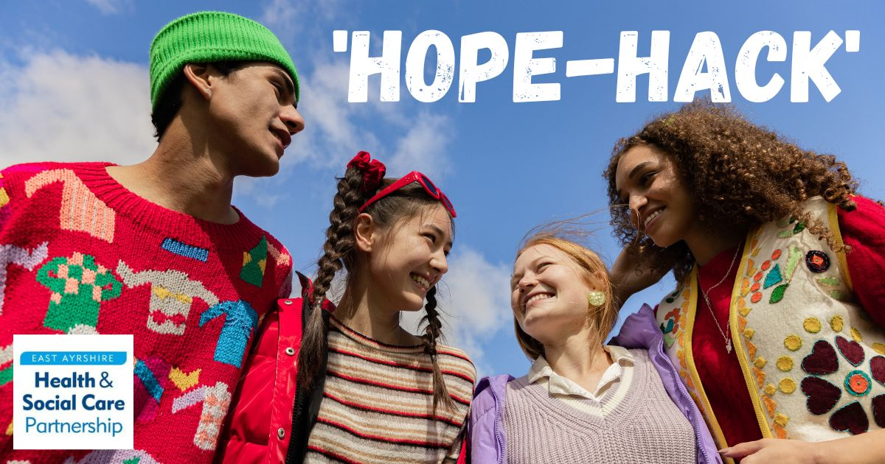

**Suggested copy**

**#1 Facebook**

Are you aged 14 – 24?

Would you like life to be better for young people in East Ayrshire?

In partnership with What Matters To You and The Hope Collective, East Ayrshire Health and Social Care Partnership is hosting a 'Hope Hackathon' event at Ayrshire College, Kilmarnock.

Come and have your say on everything from education and employability to housing, the environment and physical and mental wellbeing.

Join up to 100 other young people in East Ayrshire, test your DJ skills and be inspired to lead with special guest speaker, John Loughton.

There will also be free breakfast and lunch!

Monday 12th June

10am - 4pm

Ayrshire College, Hill Street, Kilmarnock

Find out more and register via the Eventbrite link below.

[East Ayrshire Hackathon Tickets, Mon 12 Jun 2023 at 10:00 | Eventbrite](https://www.eventbrite.co.uk/e/east-ayrshire-hackathon-tickets-634707225397)

#EAHopeHack

**#2 Facebook**

Want to have your say on issues you feel strongly about?

Want to join other people and help make a difference?

If you’re aged 14 – 24 and living in East Ayrshire, the ‘Hope Hack’ needs you!

In partnership with What Matters To You and The Hope Collective, East Ayrshire Health and Social Care Partnership is hosting a 'Hope Hackathon' event at Ayrshire College, Kilmarnock.

Come and share your views on everything from education and employability to housing, the environment and physical and mental wellbeing.

Join up to 100 other young people in East Ayrshire, test your DJ skills and be inspired to lead with special guest speaker, John Loughton.

There will also be free breakfast and lunch!

Monday 12th June

10am - 4pm

Ayrshire College, Hill Street, Kilmarnock

Find out more and register via the Eventbrite link below.

[East Ayrshire Hackathon Tickets, Mon 12 Jun 2023 at 10:00 | Eventbrite](https://www.eventbrite.co.uk/e/east-ayrshire-hackathon-tickets-634707225397)

#EAHopeHack

**#3 Twitter**

Are you aged 14 – 24 and want to improve life for young people in East Ayrshire?

Join us at Hope Hack and have your say!

Mon 12 June, @AyrshireColl Kilmarnock,

10am - 4pm

Featuring John Loughton of @daretolead

Find out more and register: tinyurl.com/bdu6bv47

#EAHopeHack

**#4 Twitter**

Want to have your say on important issues?

If you’re aged 14 – 24 and living in East Ayrshire, the ‘Hope Hack’ needs you!

Mon 12 June, @AyrshireColl Kilmarnock,

10am - 4pm

Featuring John Loughton of @daretolead

Find out more and register: tinyurl.com/bdu6bv47

#EAHopeHack